A

Report

On

Teacher’s Day 2022

Department of PHILOSOPHY

Rabindra Mahavidyalaya, champadanga,hooghly

Session: 2022-23

Theme: TEACHERS DAY

Venue: Department of PHILOSOPHY

Rabindra Mahavidyalaya, champadanga,

room no. 71

Date: 5TH September,2022

Organizer: Department of Philosophy

Objectives:

- It is a reminder of the role that teachers play in nation-building by guiding and educating the brightest minds of our country.
- To promote good relationship between teachers and students.
- To Respect the teacher's values

Summary

A Teacher’s Day is organized by the students of Philosophy Department on 5th 2022. The program began auspiciously with the lighting of the lamp by Professor Shukla Sahar in front of the portrait of Dr. Sarvepalli Radhakrishnan and garlanding by Professor Soumitra Das. Principal Sir appeared in the middle of the program and gave his valuable speech. Another departmental professor, non-teaching stuffs, Liberian was present and their presence added to the charm of the event. perform a bunch of cultural programs, such as recitals, dances, songs, speeches etc. are also held. In this program students performed a drama called 'Antesti Satkar’. They perform it very beautifully. Everyone enjoys it very much. Through various programs they try to show respect and gratitude to teachers.

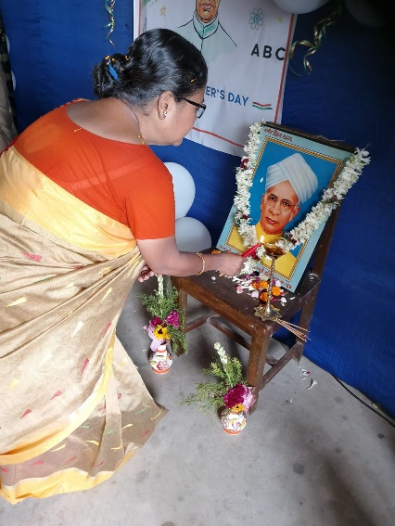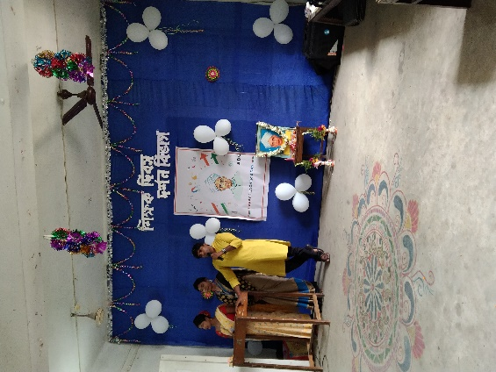
Lamp lighting by Department prof. speech by Department prof.
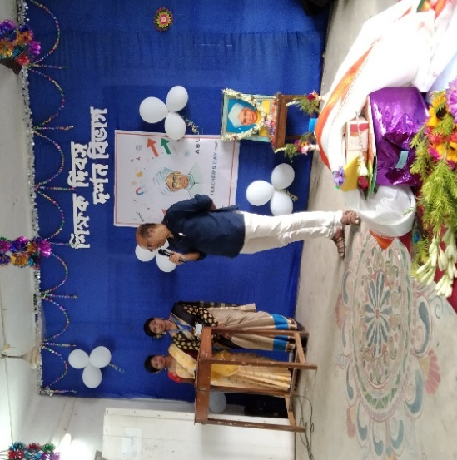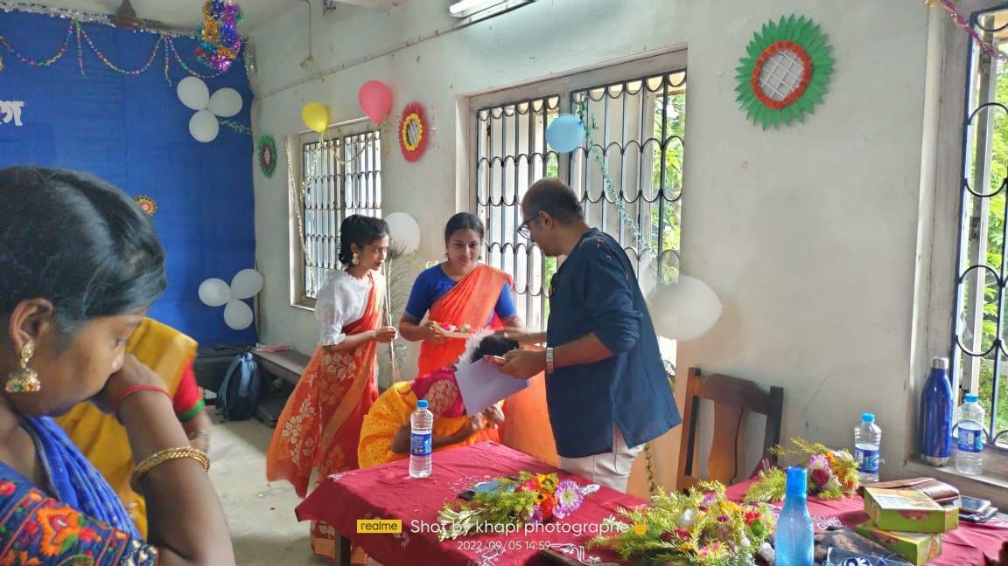
Speech by principal
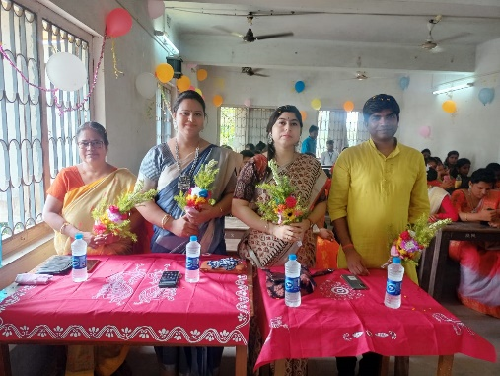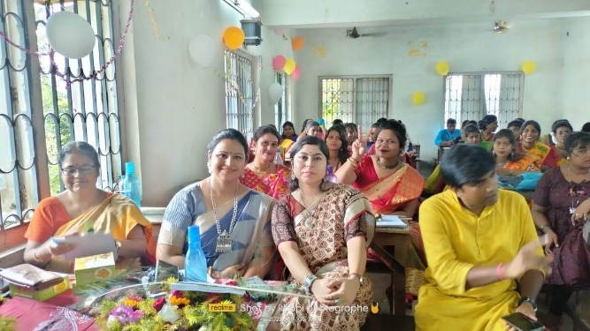
Professors of philosophy Department
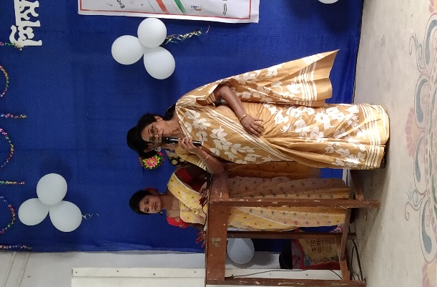
Speech by other departmental professors
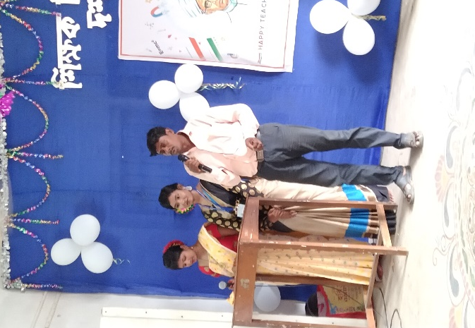
Speech by non-teaching stuff

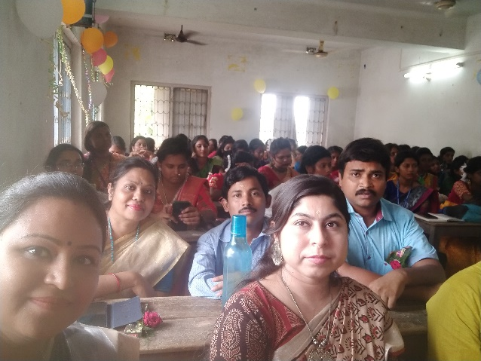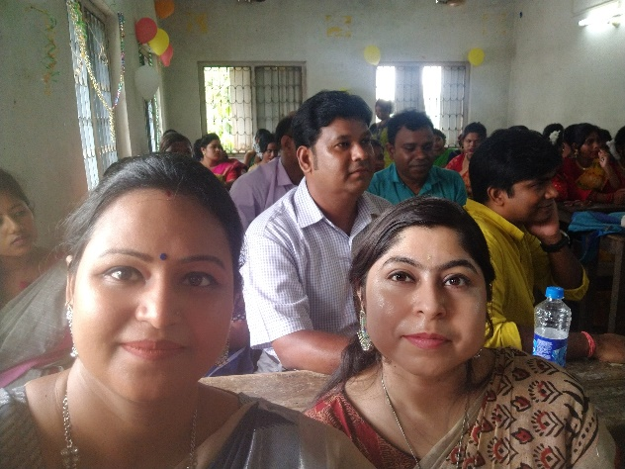
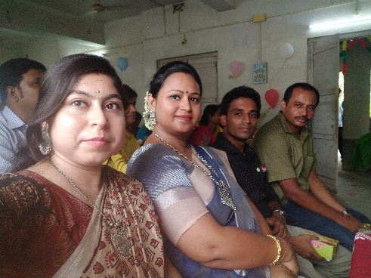
Other Departmental prof.
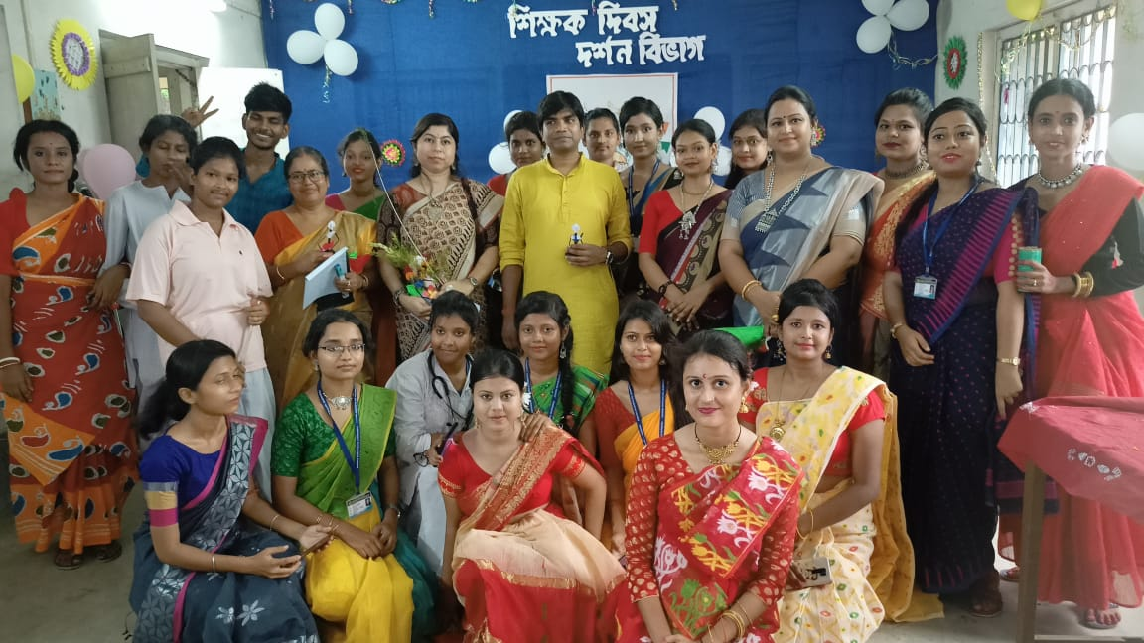
Our lovely students

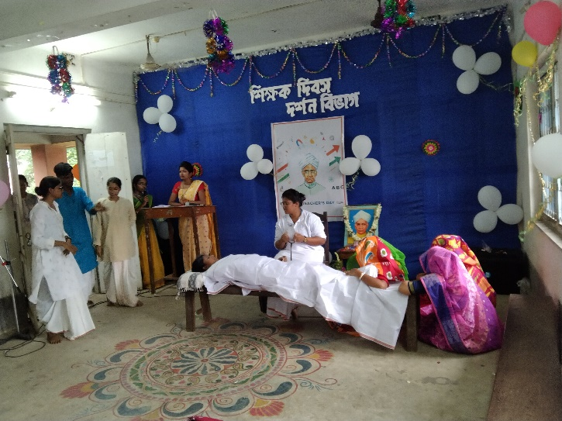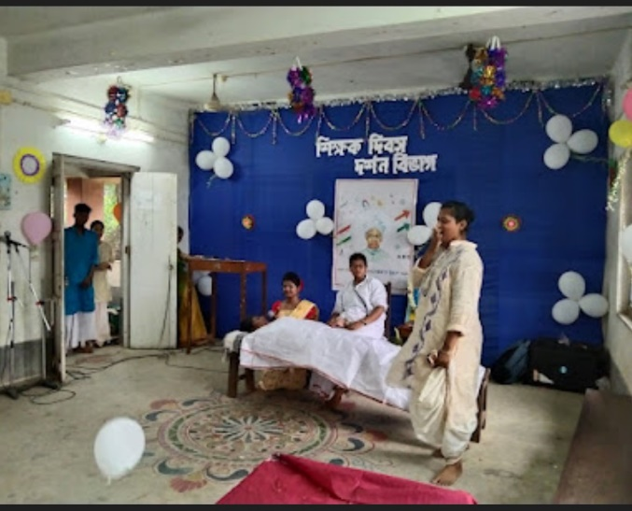
Drama performed by students

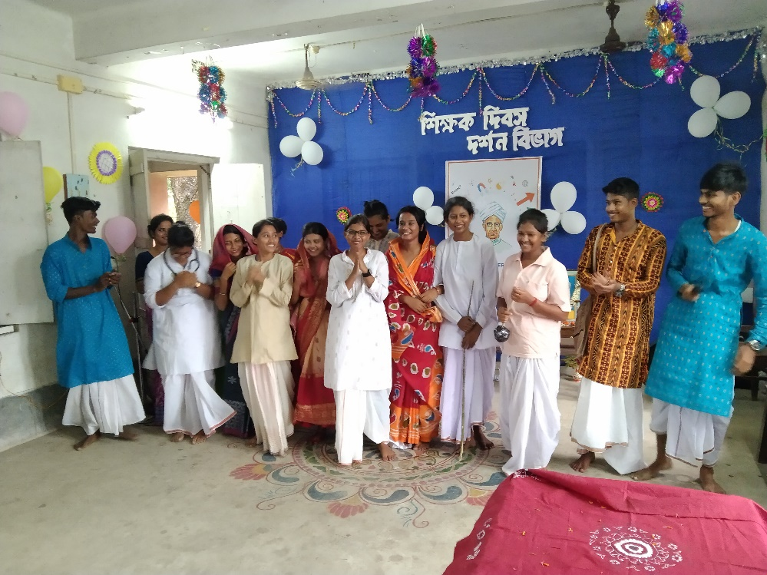
Drama team

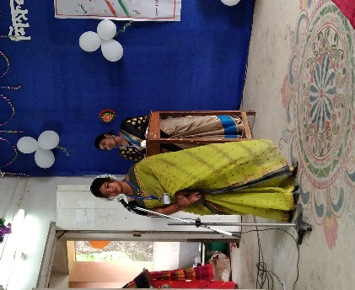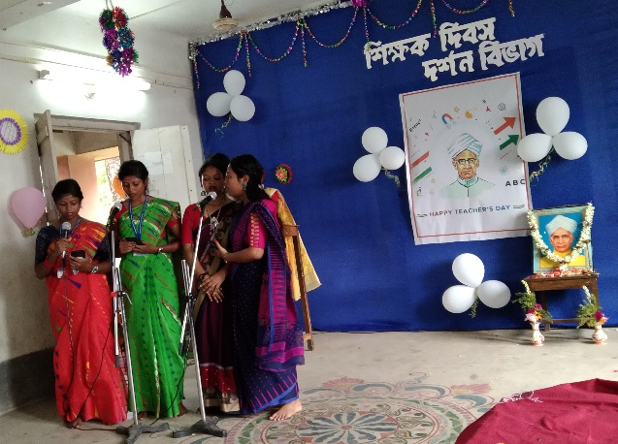
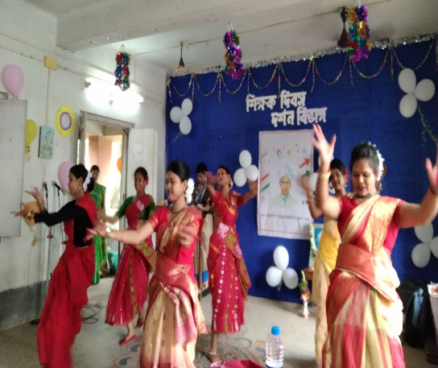
Different performances by students
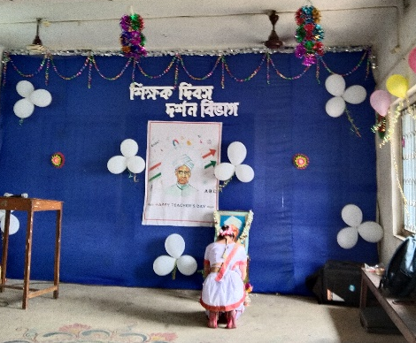

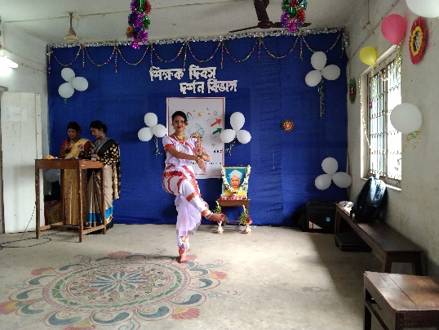

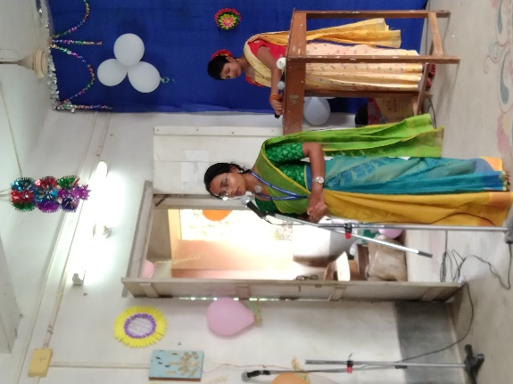
Different performances by students

Our perticipent: 80
Male:20
Female:60

Tentative programme schedule
- Inaugural session: 11 :00a.m. to 11.30 a.m.
- Inaugural Speech: 11:30 a.m. to 12.00 noon
- Cultural programme: 12:00 noonto 4:30 p.m.
- Lunch break: 1.00 p.m. to 2:00 p.m.

